Sales and Marketing Requirements Specification

Version 1.0

August 28, 2018

Table of Contents
1. Executive Summary 3
1.1 Project Overview 3
1.2 Purpose and Scope of this Specification 3
2. Product/Service Description 3
2.1 Product Context 3
2.2 User Characteristics 3
2.3 Assumptions 3
2.4 Constraints 3
2.5 Dependencies 4
3. Requirements 4
3.1 Functional Requirements 5
3.2 User Interface Requirements 5
3.3 Usability 5
3.4 Performance 6
3.4.1 Capacity 6
3.4.2 Availability 6
3.4.3 Latency 6
3.5 Manageability/Maintainability 6
3.5.1 Monitoring 6
3.5.2 Maintenance 6
3.5.3 Operations 6
3.6 System Interface/Integration 7
3.6.1 Network and Hardware Interfaces 7
3.6.2 Systems Interfaces 7
3.7 Security 8
3.7.1 Protection 8
3.7.2 Authorization and Authentication 8
3.8 Data Management 8
3.9 Standards Compliance 8
3.10 Portability 8
4. User Scenarios/Use Cases 9
5. Deleted or Deferred Requirements 9
6. Requirements Confirmation/Stakeholder sign-off 10
APPENDIX 11
Appendix A. Definitions, Acronyms, and Abbreviations 11
Appendix B. References 11
Appendix C. Requirements Traceability Matrix 11
Appendix D. Organizing the Requirements 13

Executive Summary

Project Overview
This document is meant for online shopping cloth web application is to intend to provide complete solutions of vendors as well as customers through single get way using internet. It will enable vendors to step up online shops, to browse through the shop and purchase online without visiting the shop physically. And purchasing the product online.

Purpose and Scope of this Specification
In scope
This document addresses requirements are in scope
- Purchase product
- Ordering product
- Add to cart process
- Publishing job hiring
- Get customers feedback
- Total cost/ Amount of order products
- Product Price
- Market Research
- Available stock

Out of Scope
The following processes are out of scope:
- Delivery of the product
- Employees status in relation in Human resource system

Product/Service Description
Show the product context of Sales and marketing and how does it interface with the other system.
If customer want to buy some clothes via online she/he needs to register to the online shop which scope of sales and marketing before customer get the product she/he must need to filled and do the create account, manage account, place order, add to cart and cancel if the user change his/her mind while ordering. But before that happen sales and marketing has interface to the other system such:

Human resource to get the employees hiring and support,

Ware house to order and ship the product and last is Accounting and Finance to collect the money from the customer computing and budgeting all those expenses needed.

And the admin for collecting every data entered in the system.

Product Context

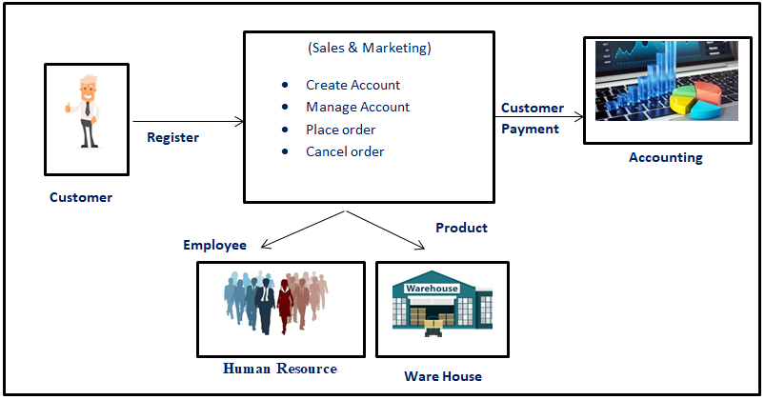

User Characteristics
Customer every customer represent as a user that takes the test of clothes online shop that we may consider as improvement in sales and marketing interface.
Staff to had a rapidly sales a staff must have a clear communication skill to customer and in system interface
Server is the system that accepts multiple connections from customer and the serves that result.
Admin has the authority to grant/delete register members as well as view profile.
Customer register members can access all the functionalities provide on website and had their own profile.

Assumptions
- User has an active internet connection or has access to one to view the website.
- The user have at least basic knowledge of computer
- The users know the English language, as user interface uses.

Constraints
Describe any items that will constrain the design options, including
- The system should build using a web page development tool like HTML, XAMPP
- The system function may have a failure such logging mostly when the user had a low internet connection.
- It may affect when operating in old system that may not compatible by their aspect and not suitable to the language they used.
- Safety of every users information entered in system that may leak because of the hackers and it will affect to the security and maintainability of the system.

Dependencies
The system depends in the following:
- It does depend in Supply Chain Management, any of the purchase product of sales and marketing has order from the stock of SCM. If SCM process occurs some failure the Sales and marketing might have a problem about the product too.
- Sales and Marketing system depend in accounting system, the data of the product that enter from Sales was direct to Accounting system.
- It depend in Human Resource system in assigning employee and also at the Employees hiring that scope of Sales and marketing and its direct from human resource system.

Requirements

Priority Definitions
The following definitions are intended as a guideline to prioritize requirements.
- Priority 1 – The user must have an account to make an order
- Priority 2 – The customer should choose at least one(1) product to be purchase
- Priority 3 – The customer should fill the form mostly the contact and address to be delivered the product
- Priority 4 – The system should be monitor at least in every day used
- Priority 5 – The system should maintainable to avoid error
- Priority 6 – The System would be nice to have notification if the product is to be delivered to notify the customers before the process.
- Priority 7 – the user account must be sent to database or either specified Account in every user to modify their own account.

Functional Requirements
Req. # | Requirement | Comments | Priority | Date Rvwd | Reviewed / Approved
1 | The system should purchase feature product that customer choose on it. | Home Page =  Purchase | 1
2 | The system should add to cart if customer had already done in shopping. | Home Page=  Ordering Product | 3
3 | The system should delete the product from customers canceled order. | Home page=  Clear cart | 1
4 | The system should view the total amount of product to be order. | Payment form=  Check total payment. | 2
5 | The system should add account that require in customer | Account Form=  User account | 3
6 | The system should click the personal data form | Personal Data=  Customer Information | 2
7 | The system should view the payment of order | Payment  Total amount | 2
8 | The system should confirm the order to proceed the order product. | Confirm Button=  To confirm the order | 3
9 | The system should generate the apply form for applying employee. | Hiring employees form=  Apply Job | 2
10 | The system should automate the feedback of the customer | Feedback form=  Suggestion and recommendation | 1
11 | The system should accept the username and password of user serve as their account | Login button=  Username and password | 3
12 | The user must register to get the shopping cart. | Registration form=  Register | 3
13 | The system should logout the account of the user. | Logout form=  logout | 1

User Interface Requirements
The various interface of the product could be:
- Login Page
- Registration Form
- Information about the product (Price, Brand, Quantity, Size, Color)
- If the user clicks the button add to cart then another screen of shopping cart should be open.

Home Page


Login Form
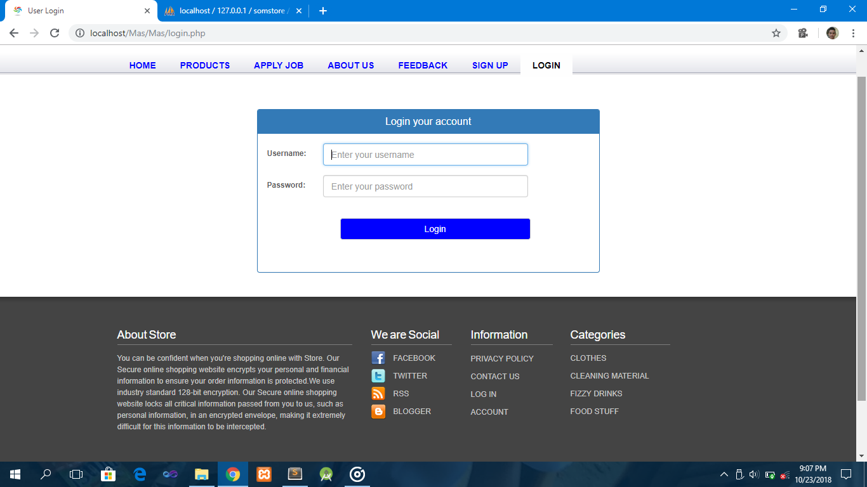

Fill-up the account form

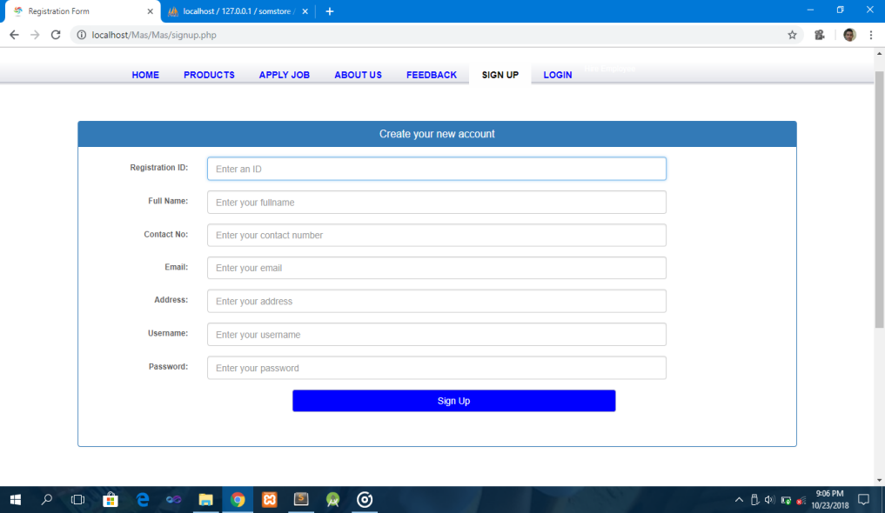

Product Details

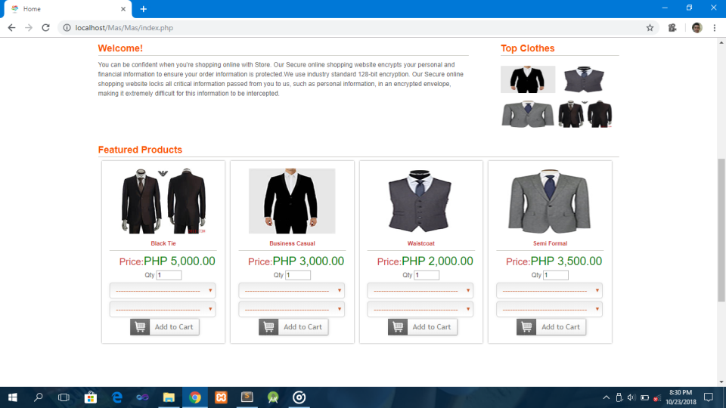

Payment Form

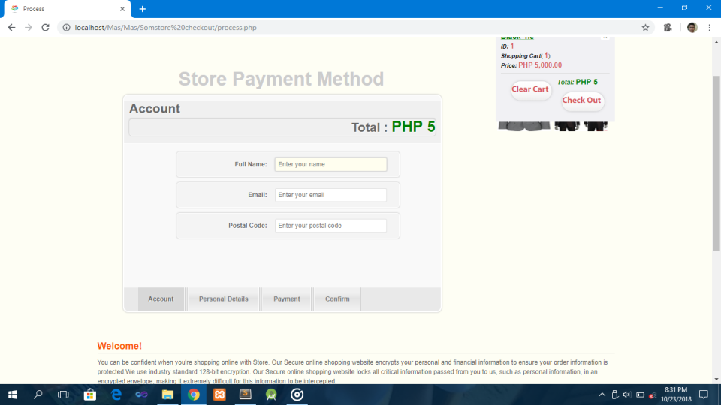

Shipping Fee Form

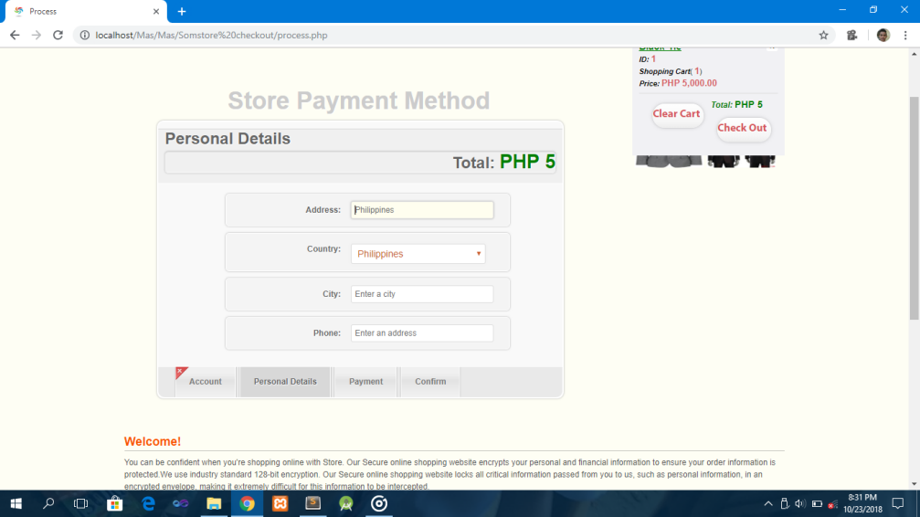

User Feedback
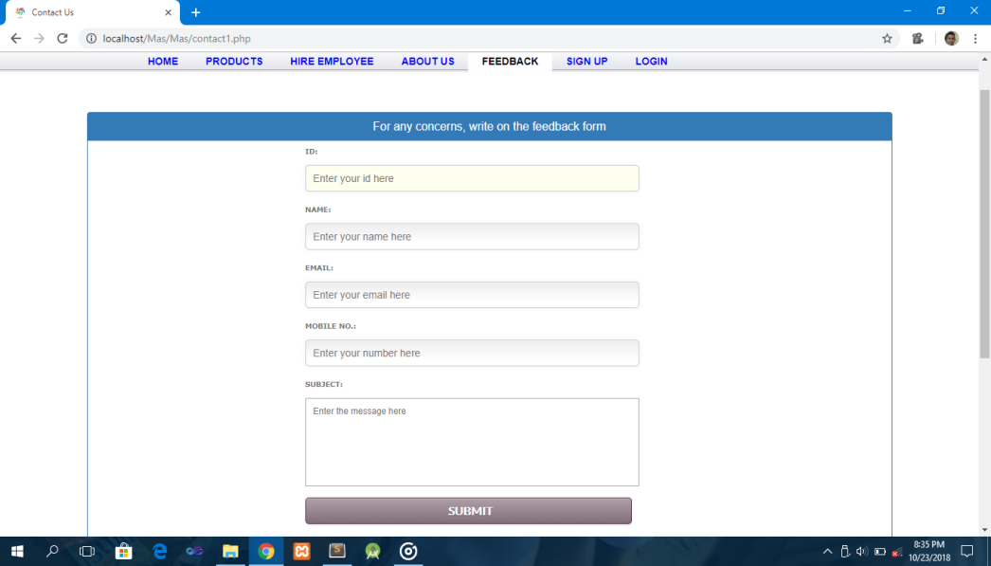

Hiring Employee’s Form
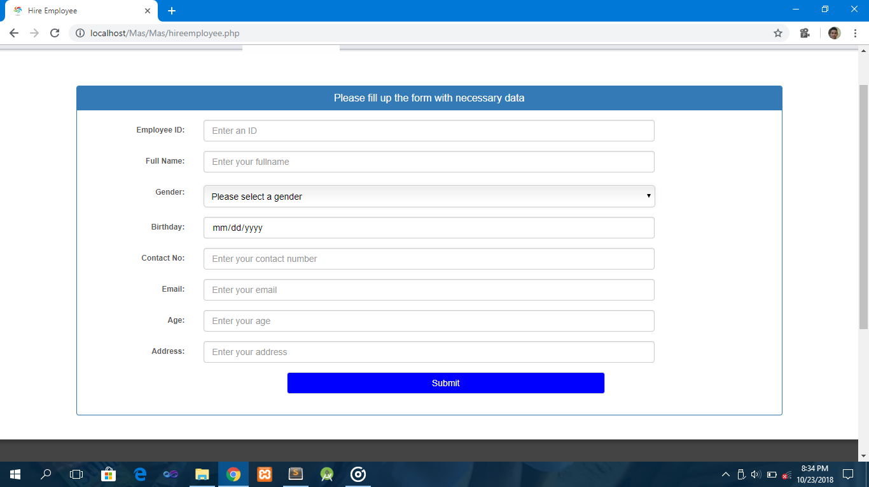

Usability
This system included the following usability:
- The documentation will serve as a guidelines to the user such:
- Viewing the ordered product – just visit your account at take a look at the cart that you’ve been ordered and it will display your order.
- Looking for total price of the product that you order? – Again go to your account and look for the payments form it already computed the total amount of your product that has been purchase.
- Want to give a recommendation, violent reaction of the product or any comments, and asking a question? – All need to do is to leave it in the users feedback form that will be direct to the admin of the system.
- User friendly it can use easily.

Performance
Specify static and dynamic numerical requirements placed on the system or on human interaction with the system:
- Static numerical requirements may include the number of terminals to be supported, the number of simultaneous users to be supported, and the amount and type of information to be handled.
- Dynamic numerical requirements may include the number of transactions and tasks and the amount of data to be processed within certain time period for both normal and peak workload conditions.
All of these requirements should be stated in measurable form. For example, "95% of the transactions shall be processed in less than 1 second" rather than “an operator shall not have to wait for the transaction to complete”.

Capacity
Include measurable capacity requirements (e.g., the number of simultaneous users to be supported, the maximum simultaneous user load, per-user memory requirements, expected application throughput)

Availability
Include specific and measurable requirements for:
- It is available only for those who had connected into internet.
- The Reliability of the system in the future users.
- The maintenance of the system should effect on availability of the procedures.
- The system can entertained customer 24/7.

Latency
Employees hiring had a delay to the system because it will depend on the strategy and decision of Human Resource.
Stock clothes/product had a minimum delay depend on the warehouse delivery procedure.
Ordering the product also had a delay because customer must need to fill-up the other form to make sure that it doesn’t any mistake and miss understand information.

Manageability/Maintainability

Monitoring
Checking the internet connection to make sure that all function of the system are correct and no error encounter.
It must need to test weekly but much better in every day before and after system used. To modified if it has error accorded.
The product to be purchase at the system also need to updates when the product is sold out it must disappear in the product display.
Monitoring the logs of the system must need to have a good communication between the system and the customer.

Maintenance
In case of failure a program will be done and the maintainability can be done efficiently. And it will directly save into the database of the system.
And always make sure that the system has a backup file with the other file and location in case of emergency, error and failure it has other system to continue the process.

Operations

- periods of interactive operations and periods of unattended operations
- data processing support functions
- disaster recovery and business resumption
- backup all the files into another drive to make sure the good condition
- Always remember to logout the account to feel safe.

System Interface/Integration
Human resource as a hiring an employee and employee to accommodate every product need to sell and give an action in every order from the customer.

Supply Chain Management to deliver the product that need to purchase in sales and marketing.

Accounting is needed to know the price and the process to the computation of totat amount of the product that sales and marketing display.

Network and Hardware Interfaces
The system must run over the internet. that all the hardware must require to connect into the internet.

Systems Interfaces
Systems interface requirements: (Joemar Apat)
The system requires the other system connected to our system which is marketing system our system requires the availability of the product price of an item that indicated in the system, Human resource will provide the information about the employee standing and information also they provide the necessary needs of the whole project, and the supply chain management will handle the raw materials for the of our company.

Security
- Security access of confidential data, user’s details can be use
- Password
- Delivery Requirements
- Flexibility service based architecture will highly desirable of future extension.
- Privacy Requirements

Protection
This system has a protection from malicious including;
- Admin can’t view user information such password
- Password encryption
- User cant login without account

Authorization and Authentication
By using the system all the user shall allow the use, view and to access the website but in terms of Authorization only those user who register and login in the website are allow to make an order and the password authentication of user should encrypted.

Data Management
Requirements to be placed in data base including;
- Registration, products, delivery details.
- Anytime
- Registration, records, hiring information
- data entities and relationships
- login with an existing account to access
- keeping data within data base and extra copies
- no registration if there is an existing account, registered account can access easily,
- 25 rows
- Text, VarChar.

Standards Compliance
All changes to a payroll database must be recorded in a trace file with before and after values.

Portability
The end user part is fully portable in any system using any web browser should be able to use the features of the system. The system shall run on Laptop, PC and Mobile Phone.

User Scenarios/Use Cases
Provide a summary of the major functions that the product will perform. Organize the functions to be understandable to the customer or a first time reader. Include use cases and business scenarios, or provide a link to a separate document (or documents). A business scenario:
- Describes a significant business need
- Identifies, documents, and ranks the problem that is driving the scenario
- Describes the business and technical environment that will resolve the problem
- States the desired objectives
- Shows the “Actors” and where they fit in the business model
- Is specific, and measurable, and uses clear metrics for success

Deleted or Deferred Requirements
Identify any requirements that have been deleted after approval or that may be delayed until future versions of the system. For example:
Req# | Business Requirement | Status | Comments | Pri | Date Rvwd | SME Reviewed /Approved
BR_LR_01 | The system should validate the relationship between Bargaining Unit/Location and Job Class. | April 2005: Deleted.  This requirement has been replaced by BR_LR_036 and BR_CC_33. | Business Process = “Assigning a Bargaining Unit to an Appointment” | 1 | 7/13/04 | Bob Dylan, Mick Jagger
BR_LR_02 | The system should validate that the supervisor indicator is correct according to job class.  Deferred to Phase 2B: 3/29/2005 | April 2005: Deferred to Phase 2B. | Business Process = “Assigning a Bargaining Unit to an Appointment” | 3 | 7/13/04 | Bob Dylan, Mick Jagger
BR_LR_03 | The system should derive the bargaining unit code, union code, and supervisor indicator from the job class code and location. | April 2005: Deleted  Replaced by BR_LR_16 and BR_LR_17. | Business Process = “Assigning a Bargaining Unit to an Appointment”; This will eliminate the need, typically, for the user to enter the bargaining unit code, union code and supervisor indicator. | 1 | 7/13/04 | Bob Dylan, Mick Jagger

Requirements Confirmation/Stakeholder sign-off
Include documentation of the approval or confirmation of the requirements here. For example:
Meeting Date | Attendees (name and role) | Comments
7/13/07 | Bob Dylan, Labor Relations SME  Mick Jagger, Labor Relations SME  Ringo Starr, Technical Project Manager  Debbie Harry, Technical Analyst  Janis Joplin, Technical Analyst  Fred Meyer, Project Manager | Confirmed BR_LR_01 – BR_LR_15
04/15/05 | Bob Dylan, Labor Relations SME  Mick Jagger, Labor Relations SME  Ringo Starr, Technical Project Manager | Deferred / Deleted: BR_LR_01 - BR_LR_04, BR_LR_07, BR_LR_12, BR_LR_14, BR_LR_15, BR_LR_06, BR_LR_17

APPENDIX
The appendixes are not always considered part of the actual Requirements Specification and are not always necessary. They may include
- Sample input/output formats, descriptions of cost analysis studies, or results of user surveys;
- Supporting or background information that can help the readers of the Requirements Specification;
- A description of the problems to be solved by the system;
- Special packaging instructions for the code and the media to meet security, export, initial loading, or other requirements.
When appendixes are included, the Requirements Specification should explicitly state whether or not the appendixes are to be considered part of the requirements.
- Definitions, Acronyms, and Abbreviations
Define all terms, acronyms, and abbreviations used in this document.
- References
List all the documents and other materials referenced in this document.
- Requirements Traceability Matrix
The following trace matrix examples show one possible use of naming standards for deliverables (FunctionalArea-DocType-NN). The number has no other meaning than to keep the documents unique. For example, the Bargaining Unit Assignment Process Flow would be BUA-PF-01.
For example (1):
Business Requirement | Area | Deliverables | Status
BR_LR_01  The system should validate the relationship between Bargaining Unit/Location and Job Class.---Comments: Business Process = "Assigning a Bargaining Unit to an Appointment" (Priority 1) | BUA | BUA-CD-01  Assign BU Conceptual Design | Accepted
 | BUA | BUA-PF-01  Derive Bargaining Unit-Process Flow Diagram | Accepted
 | BUA | BUA-PF-01  Derive Bargaining Unit-Process Flow Diagram | Accepted
BR_LR_09  The system should provide the capability for the Labor Relations Office to maintain the job class/union relationship.---Comments: Business Process = "Maintenance" (Priority 1) | BUA | BUA-CD-01  Assign BU Conceptual Design | Accepted
 | BUA | BUA-PF-02  BU Assignment Rules Maint Process Flow Diagram | ReadyForReview
For example (2):
BizReqID | Pri | Major Area | DevTstItems DelivID | Deliv Name | Status
BR_LR_01 | 1 | BUA | BUA-CD-01 | Assign BU Conceptual Design | Accepted
BR_LR_01 | 1 | BUA | BUA-DS-02 | Bargaining Unit Assignment DB Modification Description | Accepted
BR_LR_01 | 1 | BUA | BUA-PF-01 | Derive Bargaining Unit-Process Flow Diagram | Accepted
BR_LR_01 | 1 | BUA | BUA-UCD-01 | BU Assign LR UseCase Diagram | ReadyForReview
BR_LR_01 | 1 | BUA | BUA-UCT-001 | BU Assignment by PC UseCase - Add Appointment and Derive UBU | Reviewed
BR_LR_01 | 1 | BUA | BUA-UCT-002 | BU Assignment by PC UseCase - Add Appointment (UBU Not Found) | Reviewed
BR_LR_01 | 1 | BUA | BUA-UCT-006 | BU Assignment by PC UseCase - Modify Appointment (Removed UBU) | Reviewed
BR_LR_09 | 1 | BUA | BUA-CD-01 | Assign BU Conceptual Design | Accepted
BR_LR_09 | 1 | BUA | BUA-DS-02 | Bargaining Unit Assignment DB Modification Description | Accepted
BR_LR_09 | 1 | BUA | BUA-PF-02 | BU Assignment Rules Maint Process Flow Diagram | Accepted
BR_LR_09 | 1 | BUA | BUA-UCD-03 | BU Assign Rules Maint UseCase Diagram | Reviewed
BR_LR_09 | 1 | BUA | BUA-UCT-045 | BU Assignment Rules Maint: Successfully Add New Assignment Rule | Reviewed
BR_LR_09 | 1 | BUA | BUA-UCT-051 | BU Assignment Rules MaintUseCase: Modify Rule | Reviewed
BR_LR_09 | 1 | BUA | BUA-UCT-053 | BU Assignment Rules MaintUseCase - Review Assignment Rules | Reviewed
BR_LR_09 | 1 | BUA | BUA-UCT-057 | BU Assignment Rules MaintUseCase: Inactivate Last Rule for a BU | Reviewed
BR_LR_09 | 1 | BUA | BUA-UI-02 | BU AssignRules Maint UI Mockups | ReadyForReview
BR_LR_09 | 1 | BUA | BUA-TC-021 | BU Assignment Rules Maint TestCase: Add New Rule (Associated Job Class Does Not Exist) - Success | ReadyForReview
BR_LR_09 | 1 | BUA | BUA-TC-027 | BU Assignment Rules Maint TestCase: Modify Rule - Success | ReadyForReview
BR_LR_09 | 1 | BUA | BUA-TC-035 | BU Assignment Rules Maint TestCase: Add New Rule (Associated Job Class Does Not Exist) - Error Condition | ReadyForReview
BR_LR_09 | 1 | BUA | BUA-TC-049 | BU Assignment Rules Maint TestCase: Modify Rule - Error Condition | ReadyForReview
For example (3):
BizReqID | CD01 | CD02 | CD03 | CD04 | UI01 | UI02 | UCT01 | UCT02 | UCT03 | TC01 | TC02 | TC03 | TC04
BR_LR_01 |  |  | X |  | X |  | X |  |  | X |  | X
BR_LR_09 | X |  |  | X |  | X |  |  | X |  | X |  | X
BR_LR_10 | X |  |  | X |  |  |  |  | X |  | X
BR_LR_11 |  | X
- Organizing the Requirements
This section is for information only as an aid in preparing the requirements document.
Detailed requirements tend to be extensive. Give careful consideration to your organization scheme. Some examples of organization schemes are described below:
By System Mode
Some systems behave quite differently depending on the mode of operation. For example, a control system may have different sets of functions depending on its mode: training, normal, or emergency.
By User Class
Some systems provide different sets of functions to different classes of users. For example, an elevator control system presents different capabilities to passengers, maintenance workers, and fire fighters.
By Objects
Objects are real-world entities that have a counterpart within the system. For example, in a patient monitoring system, objects include patients, sensors, nurses, rooms, physicians, medicines, etc. Associated with each object is a set of attributes (of that object) and functions (performed by that object). These functions are also called services, methods, or processes. Note that sets of objects may share attributes and services. These are grouped together as classes.
By Feature
A feature is an externally desired service by the system that may require a sequence of inputs to affect the desired result. For example, in a telephone system, features include local call, call forwarding, and conference call. Each feature is generally described in a sequence of stimulus-response pairs, and may include validity checks on inputs, exact sequencing of operations, responses to abnormal situations, including error handling and recovery, effects of parameters, relationships of inputs to outputs, including input/output sequences and formulas for input to output.
By Stimulus
Some systems can be best organized by describing their functions in terms of stimuli. For example, the functions of an automatic aircraft landing system may be organized into sections for loss of power, wind shear, sudden change in roll, vertical velocity excessive, etc.
By Response
Some systems can be best organized by describing all the functions in support of the generation of a response. For example, the functions of a personnel system may be organized into sections corresponding to all functions associated with generating paychecks, all functions associated with generating a current list of employees, etc.
By Functional Hierarchy
When none of the above organizational schemes prove helpful, the overall functionality can be organized into a hierarchy of functions organized by common inputs, common outputs, or common internal data access. Data flow diagrams and data dictionaries can be used to show the relationships between and among the functions and data.
Additional Comments
Whenever a new Requirements Specification is contemplated, more than one of the organizational techniques given above may be appropriate. In such cases, organize the specific requirements for multiple hierarchies tailored to the specific needs of the system under specification.
There are many notations, methods, and automated support tools available to aid in the documentation of requirements. For the most part, their usefulness is a function of organization. For example, when organizing by mode, finite state machines or state charts may prove helpful; when organizing by object, object-oriented analysis may prove helpful; when organizing by feature, stimulus-response sequences may prove helpful; and when organizing by functional hierarchy, data flow diagrams and data dictionaries may prove helpful.

